## Connecting to the EC2 Instance

After downloading and configuring the vpn, you should be able to access your team's server from the browser. The config files can be found in the “team-x.zip” found in your team’s github repository. Simply type that IP address into your browser to connect to the instance.

You should see the following screen:

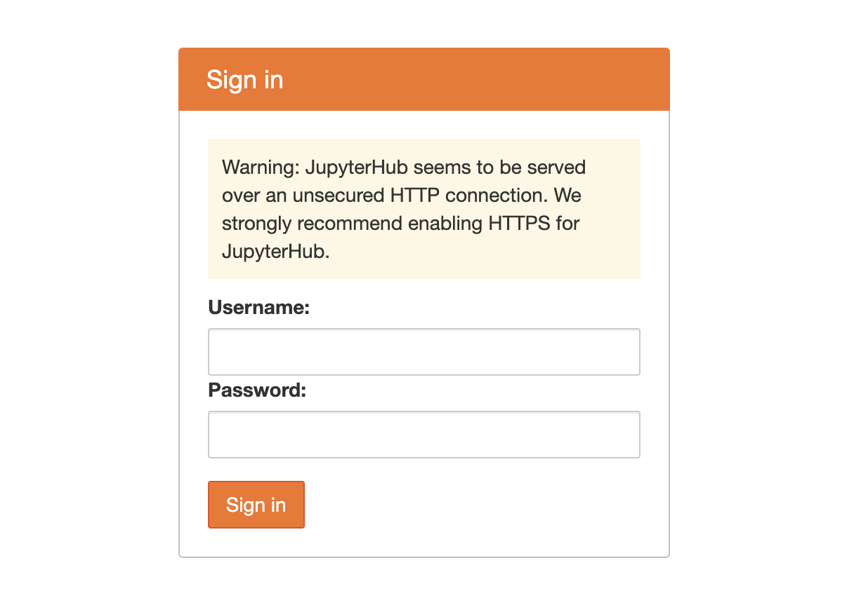

Each server has premade users you will login as:

* user-1
* user-2
* user-3
* user-4
* user-5
* user-6
* user-7
* user-8

To set a password, simply put in one of the above usernames and your desired password in the field. This will both set the password and log you in, **so be sure to remember the password you set.**

Once logged in, you should see the following:

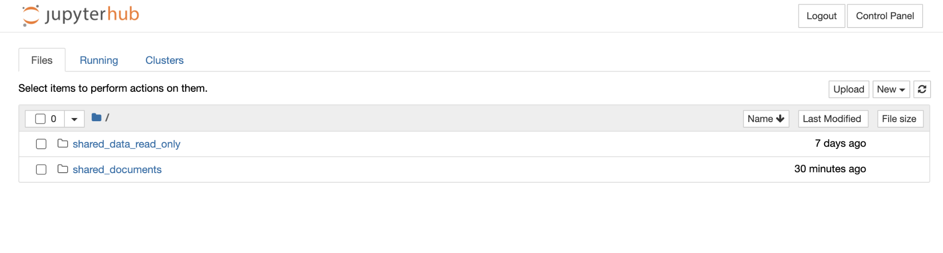

This directory is your user’s local files. You should be able to create, upload, delete and edit files into this directory, with the following provided directories:

* Shared_data_read_only - this directory has the sample data you will need. Everyone on the team can download these folders, but not make any changes to them. You can download anything within and edit how you please, but the contents of this directory cannot be changed directly.
* Shared_documents - this folder is shared across all users on your team, and the contents can be edited however you please. This should be the collaborative folder your team will be using to share documents.

From this directory, you should be able to add a notebook with either R or Python 3, as follows:

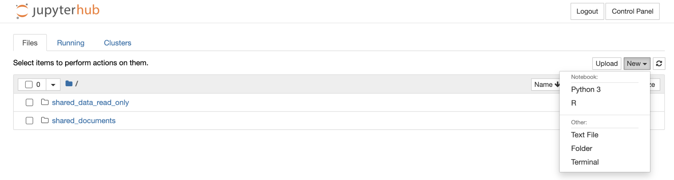

## 

## Changing the interface to JupyterLab or nteract

You can access different interfaces by just changing the URL

JupyterLab: simply remove the trailing “/tree” and replace it with “/lab”, as seen below

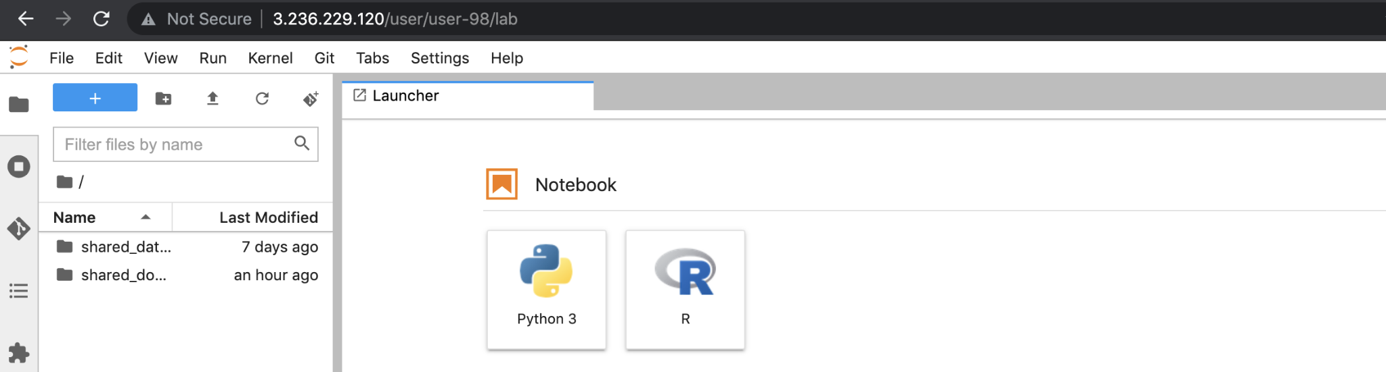

Within JupyterLab, you can integrate directly with the github repo with the plugin on the left by selecting “clone a repository”:

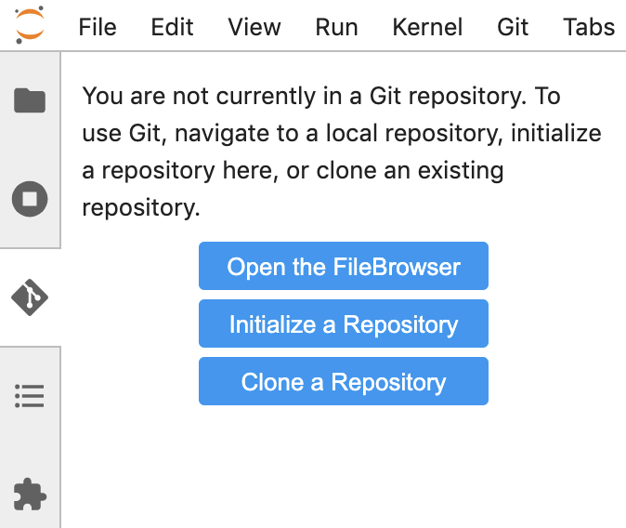

nteract: replace the trailing “/tree” with “/nteract”

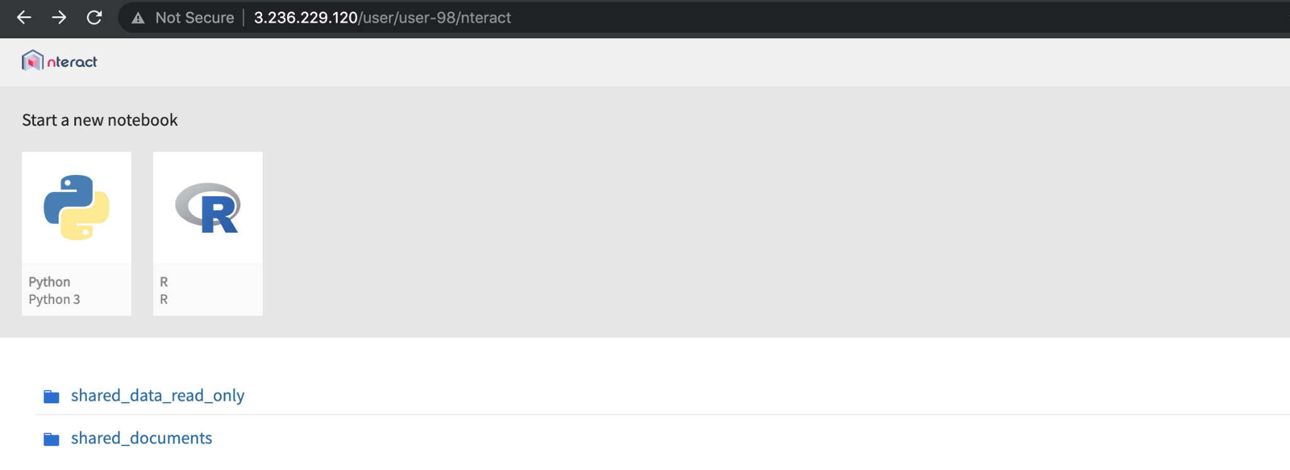

## Using R Studio

R Studio is also installed on the server. Simply add :8787 to the end of the IP address to access this page. You should be greeted with the following :

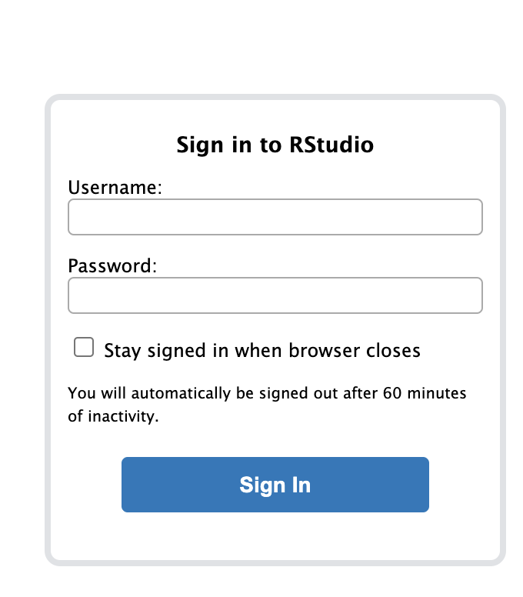

Use the following credentials to get in:

Username: rstudio

Password: rstudio

This should log you in, and you should see the following: 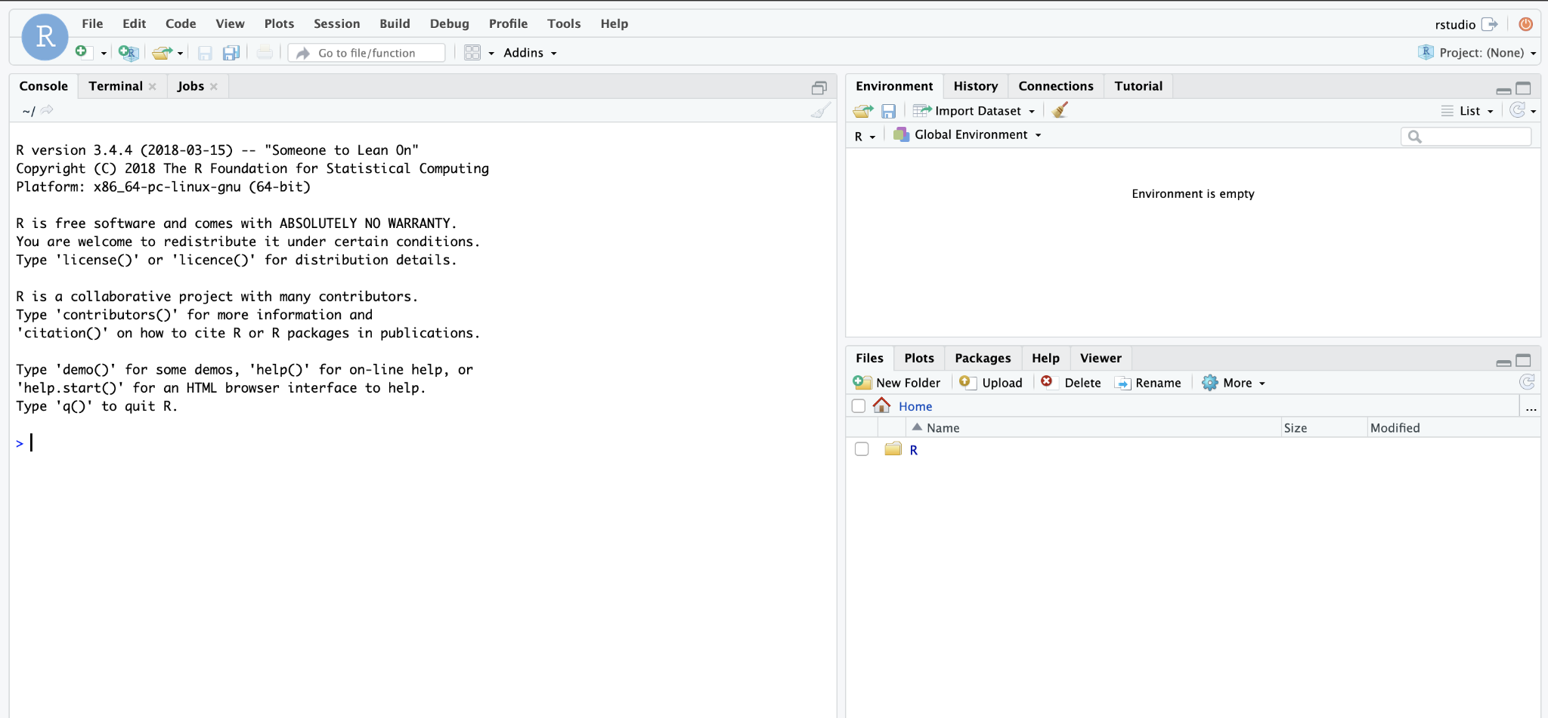

# Installing addition libraries

You should be using pip to install any libraries you need. This can be done by opening the terminal and typing commands in the form of:

* pip install <package-name>